### **User Manual for Task Manager GUI App**

#### **Table of Contents**

1. Introduction
2. Installation
3. Getting Started
4. Features
5. Troubleshooting
6. FAQs

### **1. Introduction**

Welcome to the Tkinter Task Manager GUI App! This application helps you manage your tasks efficiently with an easy-to-use graphical interface.

### **2. Installation**

**Step 1:** Ensure you have Python installed on your system. You can download it from python.org.

**Step 2:** Install Tkinter if it’s not already installed. You can do this using pip:

pip install tk

**Step 3:** Download the Task Manager app files from the provided repository or source.

**Step 4:** Navigate to the directory containing the app files and run the application:

python task_manager.py

### **3. Getting Started**

**Step 1:** Launch the application by running the GUIappLaurettaNdemanu2.py script.

**Step 2:** The main window will appear, displaying the task list and control buttons.

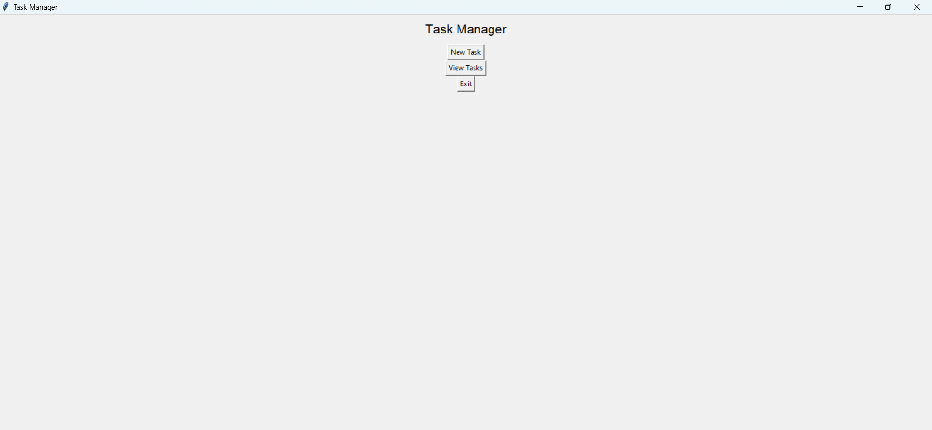

**Step 3:** To add a new task, click the “New Task” button. Enter the task details in the popup window, the tasks priority number, then click “Save”.

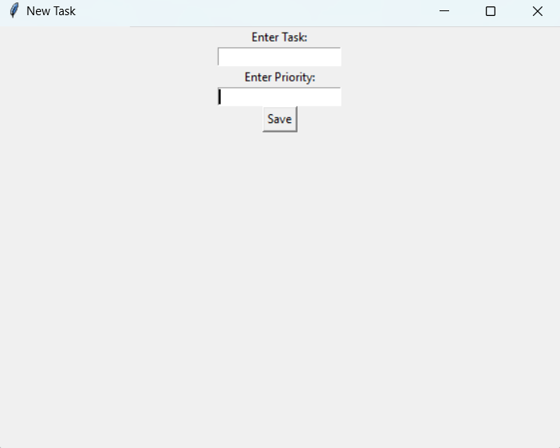

**Step 4:** To view a task, select the “View Tasks” button.

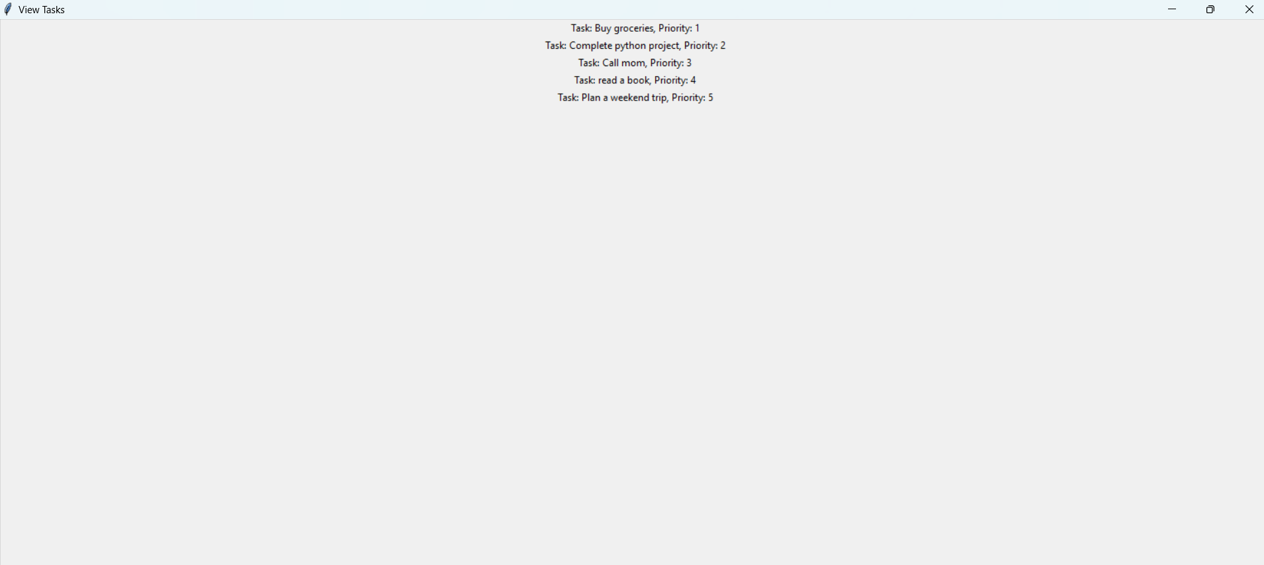

### **4. Features**

* **Add Task:** Allows you to add new tasks with details such as title, description, and priority number.
* **Complete Task:** Marks a selected task as completed.
* **View Tasks:** Displays all tasks in a list format with their status.

### **5. Troubleshooting**

* **Issue:** The app doesn’t start.
  + **Solution:** Ensure Python and Tkinter are installed correctly. Check for any error messages in the terminal.
* **Issue:** Tasks are not saving.
  + **Solution:** Verify that you have write permissions in the directory where the app is running.

### **6. FAQs**

* **Q:** Can I edit a task after adding it?
  + **A:** Currently, the app does not support editing tasks. You can delete and re-add the task with updated details.
* **Q:** Is there a way to sort tasks?
  + **A:** Sorting functionality is not available in this version but may be added in future updates.

### 